#Section#

**#General Knowledge#**

#Question#

#Chapter#042 #QuestionType# 2 #Alignment# V #LOD# 2 #Author# Eptitude

#Q# The Cripps Mission visited India during the regime of?

1. Jdflkjflsad
2. 2.kdjlvsd
3. Ldkfjvd;lfgkvds;

#Option# Lord Linlithgow

#Option# Lord Mountbatten

#Option# Lord Wavell

#Option# Lord Wellington

#Solution# Option 1

#CorrectOption# 1

#Question#

#Chapter#042 #QuestionType# 2 #Alignment# V #LOD# 2 #Author# Eptitude

#Q# The Cripps Mission visited India during the regime of?

1. Jdflkjflsad
2. 2.kdjlvsd
3. Ldkfjvd;lfgkvds;

#Option# Lord Linlithgow

#Option# Lord Mountbatten

#Option# Lord Wavell

#Option# Lord Wellington

#Solution# Option 1

#CorrectOption# 1

#Explanation#dvnienvienvinen

#Question#

#Chapter#042 #QuestionType# 2 #Alignment# V #LOD# 2 #Author# Eptitude

#Q# The Cripps India during the regime of?

1. Jdflkjflsad
2. 2.kdjlvsd
3. Ldkfjvd;lfgkvds;

#Option# Lord Linlithgow

#Option# Lord Mountbatten

#Option# Lord Wavell

#Option# Lord Wellington

#Solution# Option 1

#CorrectOption# 1

#Section#

**#Power#**

#Question#

#Chapter#042 #QuestionType# 2 #Alignment# V #LOD# 2 #Author# Eptitude

#Q# The Cripps of?

1. Jdflkjflsad
2. 2.kdjlvsd
3. Ldkfjvd;lfgkvds;

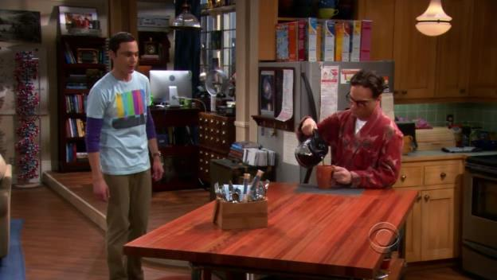

#Option# Lord Linlithgow

#Option# Lord Mountbatten

#Option# Lord Wavell

#Option# Lord Wellington

#Solution# Option 1

#CorrectOption# 1

#Question#

#Chapter#042 #QuestionType# 2 #Alignment# V #LOD# 2 #Author# Eptitude

#Q# visited India during the regime of?

1. Jdflkjflsad
2. 2.kdjlvsd
3. Ldkfjvd;lfgkvds;

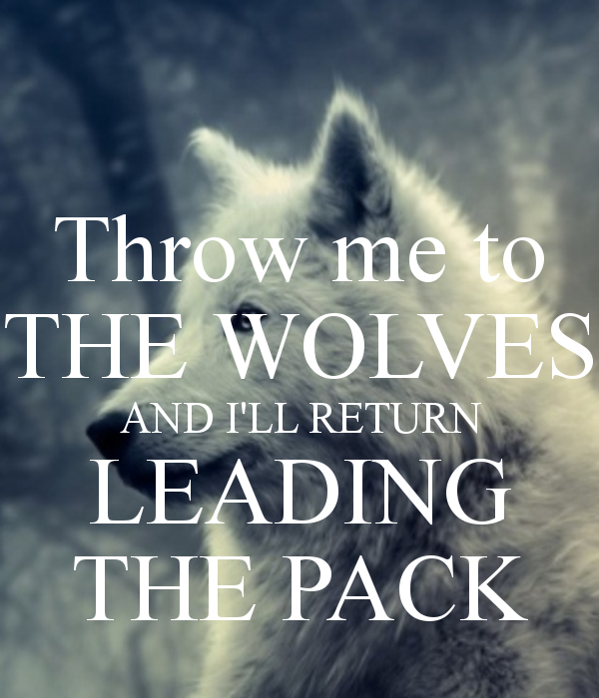#Option# Lord Linlithgow

#Option# Lord Mountbatten

#Option# Lord Wavell

#Option# Lord Wellington

#Solution# Option 1

#CorrectOption# 1